**`**

|  |
| --- |
|  |

|  |  |
| --- | --- |
|  | **ASSIGNMENT TOP SHEET**  **Higher National Diploma in Information Technology**  **Sri Lanka Institute of Information Technology** |

|  |  |  |  |
| --- | --- | --- | --- |
| Student Registration Number | Student Name | | |
| IT18200584 | S.Ramsunthar | | |
| IT18200720 | S.Gugatharsan | | |
|  |  | | |
|  |  | | |
| Module Title :Web Application Development | | | Module Code: N107 |
| Lecturer in charge : Ms. Gayana Fernando | | | |
| Assignment Title : Tecknel online site | | | |
| Due Date: 26th January 2019 | | Date Submitted: 25th January 2019 | |
| Please Tick here if you have used a proof-reader for this assessment : | | | |
| Turnitin Paper ID* | | | |

*Not required if not submitting via Turnitin

SLIIT Academy Logo Final Colour

|  |  |
| --- | --- |
| **Declaration** | |
| We declare that work presented in the assignment submitted to the Sri Lanka Institute of Information Technology is a record of an original work done by us*.* This assessment is submitted in the partial fulfilment of the requirement for the award of the degree of Bachelor of Science in Information Technology. The results embodied in this report have not been submitted to any other University or Institution for the award of any degree or diploma. Information derived from the published or unpublished work of others has been acknowledged in the text and a list of references is given. | |
| *Name(s) and Signature(s) :*  S.Ramsunthar  S.Gugatharsan | *Date:*  *24/01/2019*  *24/01/2019* |

# **Introduction and Description of the Project**

Our project is to create a website to e-business enterprise to make their system portable and easier to use. All of their work can be done very easily in this website.

# **Problem Specification**

# Tecknel is a computer shop, which sells laptops, PCs, monitors, graphics cards etc. This shop fully working as a manual system. So they face lots of problem such as labor cost, maintaining stock details, maintaining customer details and so on. So we decided to do a website to change their system into a fully online one.

# **Solution Outline**

By changing their system into online will help to easily maintain the stock details, customer details. No need to have labor. Allocating accounts for user to do purchase and view things and tracking orders. We have simplified our model and want to reflect these changes in our online system. The current system is difficult to work with so this is a good incentive to review the whole platform.

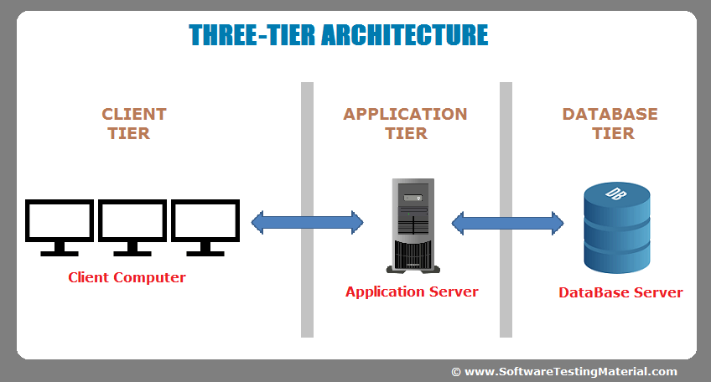

# **Key Benefits**

* Improve the business by making it online. It helps to spread their business.
* Making it user friendly.
  + Using simple design.
* Having separate sections for everything
  + For users
    - Allocating account to do purchase, track order etc.(only for registered users)
  + For admin(management)
    - Handling everything such as member section, stock section etc.
  + Having payment section.

**2. Details of System Functions*:***

**Name:** User Account

**Description:** The system should get the valid details from the customer and create an account before purchase any product. Customer should provide all the details for billing and shipping.

**Name:** Purchase History

**Description:** After purchasing a mobile customer can see the purchase date, quantity and the address where they need to receive the order.

**Name:** Order Tracking

**Description:** After purchase the products it can track and see the path of receive the items.

**Name:** Shopping Cart

**Description:** This allowsusers to select the products they want and then go to the check out for payment.

**Name:** User Management

**Description:** It manages the user profiles and the user details that have been registered in the system. And it also controls the wish lists, watch lists, favorite products of the particular customer.

**Name:** Product Management

**Description:** This is the main part of the e-commerce system and provides all the features for product placement, order fulfilment etc. This is the key to manage online sales. The products can be search by category and subcategory.

**Name:** Order management

**Description:** It takes the information on the registration database, the data in the basket, the delivery information and verification data relating to the payment. The order is the card that summarizes all the delivery and order information to enable correct delivery. It includes

* List of products purchased
* User information
* Details of places to delivery
* Delivery time information
* Payment information

**Name:** FAQ Management

**Description:** Here it controls the Frequently Ask Questions (FAQ) by the customers where the answers are given for the common questions that would be ask by the customer. And also it gives quick responses to the customers about the products.